2012 Chimney Swift Sit Results
Audubon Minnesota
October 1, 2012

Thank you Ron!

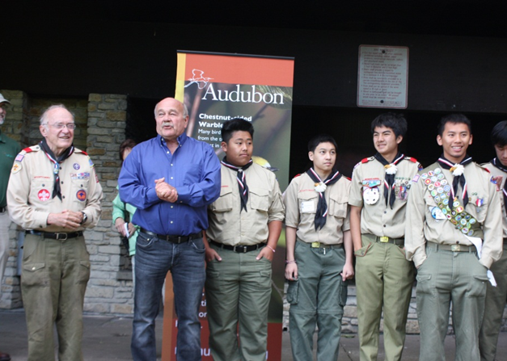
First, a big Thank You to Ron Windingstad for organizing the 2012 Chimney Swift Sit! Ron retired from Audubon Minnesota on September 7th after leading Audubon Minnesota’s Audubon at Home program for six years. During this time he focused conservation attention on the plight of the Chimney Swift and engaged hundreds of youth in the Twin Cities and outstate in conservation education and management. Together, these young adults constructed nearly 100 chimney swift towers throughout the state! Ron will now be checking up on those swifts during migration as they pass through Mexico and Centro America! We (and the swifts) wish him well!

2012 Results

Our annual Chimney Swift Sit in 2012 included two official count periods:
- July 20th-July 23rd; and
- August 31-September 3rd.

In addition to these two count periods, many volunteers counted at sites on days between the two count periods as well as one day after (September 4th). The total number of volunteers engaged from July 20th through September 4th was 299; the total number of sites monitored was 91. A total of 11,793 chimney swifts were counted. Below, we report on the total number of observers, sites, and chimney swifts that were counted within the two official count periods.

First Official Count Period: July 20th-July 23rd

Sixty-six volunteers counted chimney swifts at 33 buildings during the first official count period in late July. A total of 2,313 chimney swifts were counted. Sites that were monitored included businesses, churches, schools, artificial towers and apartment buildings. Figure 1 illustrates the types of buildings that were monitored and used; Figure 2 illustrates the number of swifts by building type. During the first count period nearly 68% of all the swifts observed were at chimneys at schools.

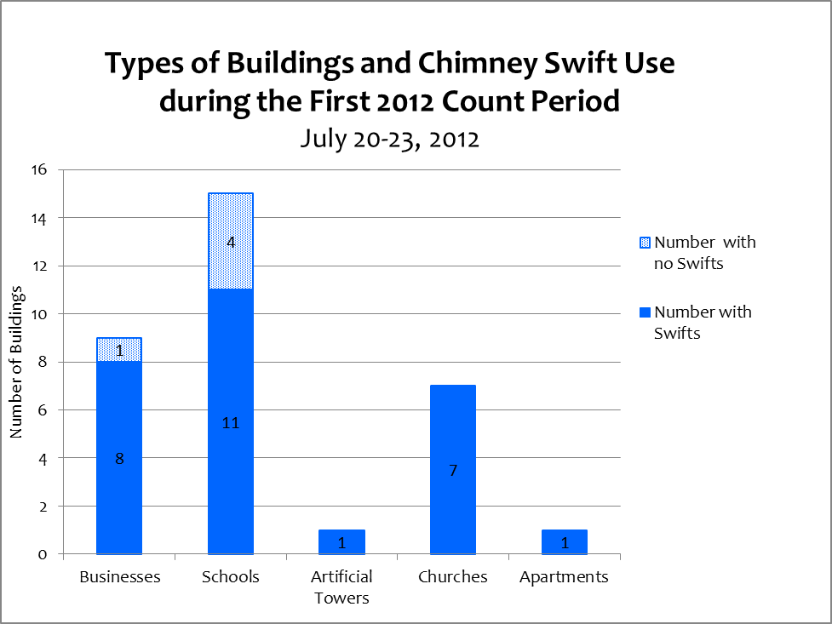

F

Figure 1
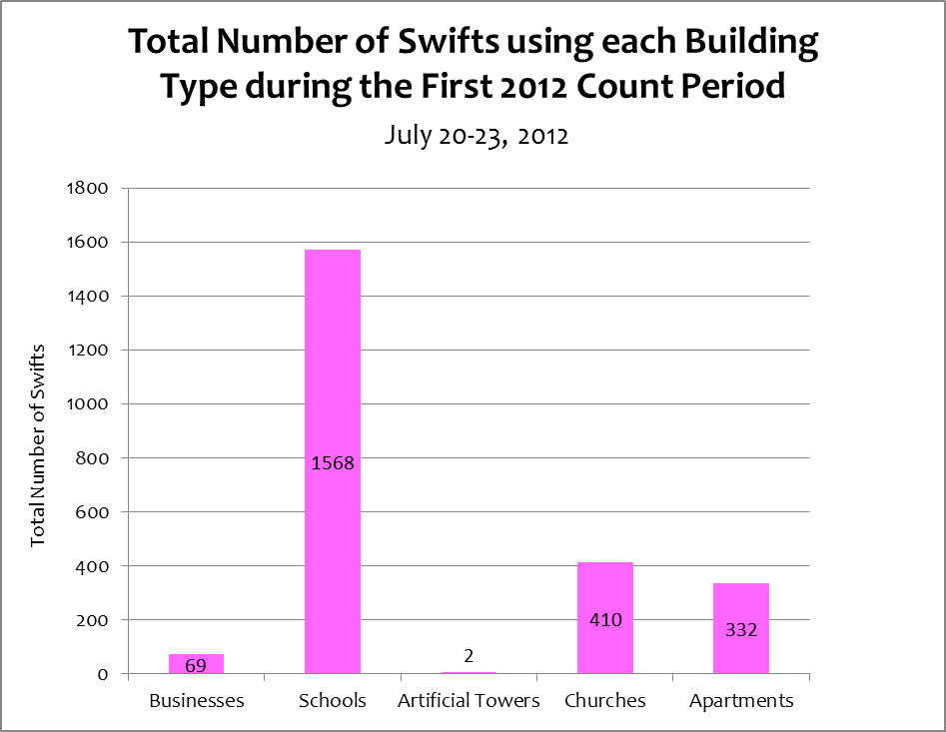

Figure 2
Interesting Notes during the First Official Count Period:
- The one artificial tower that was monitored had a camera within the chimney that showed a pair of swifts was still sitting on five eggs in late July.
- Observers reported that one school where 210 chimney swifts were seen, Wildwood Elementary (Mahtomedi), is likely to be demolished in the coming school year.
- The highest number of swifts was observed at the Hillside Apartment Building in Rochester, Minnesota. Although high, the observer has counted chimney swifts at this site many times over the past 15 years, often numbering between 400-600 birds. The numbers, however, these past two years have been much lower.

Second Official Count Period: August 31st-September 3rd

One hundred nineteen volunteers counted chimney swifts at 51 buildings during the second official count period in late August-early September. A total of 4,317 chimney swifts were counted. Sites that were monitored included businesses, churches, schools, artificial towers, apartment buildings and home residences. Figure 3 illustrates the types of buildings that were monitored and used; Figure 4 illustrates the number of swifts by building type. During the second count period 44% of all the swifts observed were at chimneys at apartments; over 81% of the swifts observed were at apartments and schools.

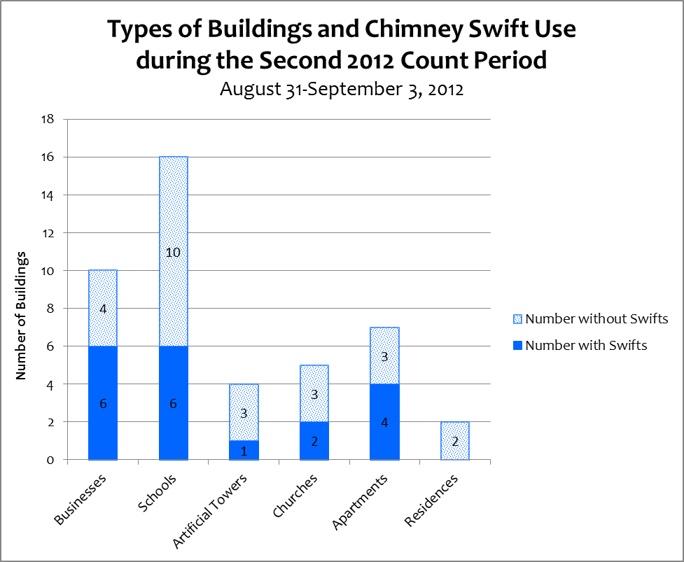

Figure 3
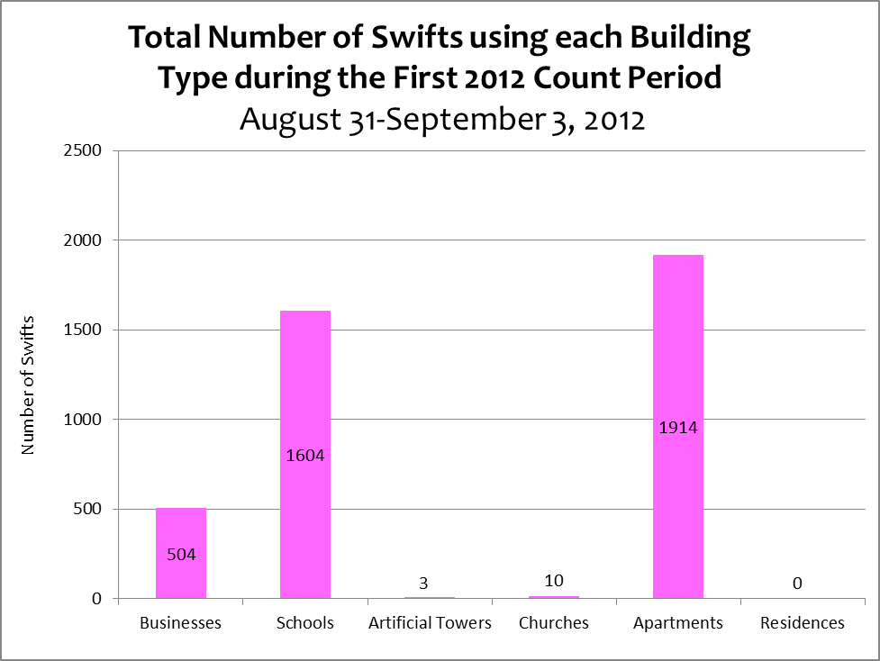

Figure 4

Interesting Notes during the Second Official Count Period:
- At a business site in downtown Willmar, a hawk was observed perched on the chimney (perhaps a Sharp-shinned), apparently waiting to grab a swift that got too close. As the observers watched it made three very close attempts before grabbing one swift and killing it on the chimney. After pulling out some feathers and eating some of it, the hawk flew away with its prize. The recurring presence of the hawk dropped the numbers of swifts by 50 - 100 birds from the number observed earlier in the week when no hawk was present.
- The highest number of swifts was observed at a school in Elk River where approximately 930 swifts were seen.

Figure 5 compares the total number of chimney swifts observed during the two count periods. Combined, 6,630 swifts were reported during the official count time frames; nearly twice as many swifts were reported during the second reporting period.

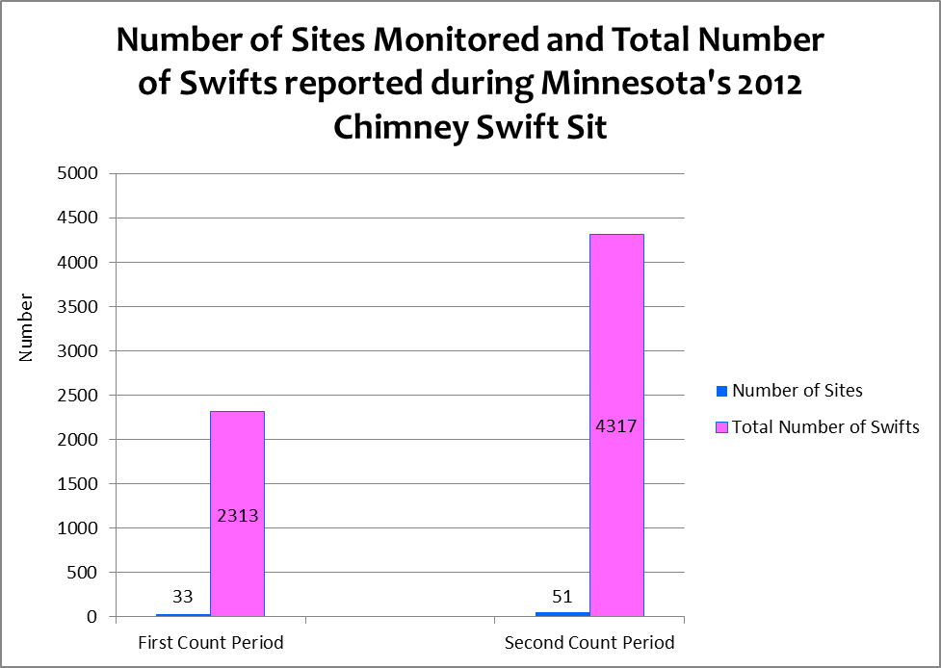
Figure 5

THANK YOU to everyone who participated in the 2012 Sit! And to those of you who introduced new Sitters to the joys of Swifting –thank you.

Audubon Minnesota
2357 Ventura Drive
Suite 106
St. Paul, Minnesota 55125

